PHASE 3: SUBMISSION CHECKLIST/SIGNOFF SHEET
GROUP#: 1 GROUP NAME: Dashers

Deliverables:
- [Revised] Description of the organization
- [Revised] ER diagram with min/max specifications
- [Revised] Constraints not in ER diagram
- [Revised] Relational Schema with Referential Integrity
- [Revised] Queries with brief description
- [Revised] DML + DDL + SQL statements
- [Revised] Completed PostgreSQL Implementation (Attached Team SQL script)
- Completed ORM Implementation
Assessment:
- Group Status Report

We have each reviewed the contents of this deliverable.

Phase Leader Abinaya Ramesh _________________

Phase Recorder Zubair Zaki _________________

Phase Checker Lingjie Liao _________________

Technical Advisor Kellie Clinton _________________

1. Introduction
This project, the Supermarket Management System, is designed to provide a centralized and structured repository for core business data, including customer transactions, product inventory, and employee information. The primary focus of this project is to establish a foundation for a comprehensive system that can support the complex data requirements of a modern retail environment.
2. Description of the Supermarket Database
The Supermarket Database (SUPERMARKET) stores essential information required to manage the day-to-day operations of a retail store. The database contains data about customers, products, transactions, employees, stores, and inventories, ensuring that all activities within the supermarket are properly recorded and interconnected.

- Customers: Customers are represented in the database with a unique Customer_ID, along with attributes such as Customer_Name, Customer_Age, Customer_Address, and Customer_Membership. Each customer can make one to many transactions, and one transaction can only be made by one to one customer.
- Products: Products are uniquely identified by a Product_ID and described by attributes such as Product_Name, Product_Type, Product_Price, and Product_Unit_of_Measure. Products can be included by showing the Product_Quantity by one to many transactions and a transaction can include one to many products.
- Transactions: Transactions record purchase activities carried out in the supermarket. Each transaction has a unique Transaction_ID and other details such as Transaction_Workstation, Transaction_Date, Transaction_Total_Amount, Transaction_Payment_Method. One transaction can only be made by one to one customer, but one customer can make one to many transactions. One Employee can record one to many transactions, but one transaction can only be recorded by one to one employee. Each transaction can include one to many products, and each product includes one to many transactions.
- Stores: Each store in the organization is uniquely identified by a Store_ID and includes attributes such as Store_Address, Store_Phone_Number, Store_Name and Store_Owner_Name. Stores will hire one to many employees, one employee can be hired one to many stores. Each store maintains one to many restocks, but one restock is maintained one to one store. Stores can process zero to many transactions, but a transaction can only process one to one store.
- Employees: Employees are tracked in the database with a unique primary Employee_ID and unique candidate Employee_SSN. Another attribute Employee_Address and Employee_Name is included. Employees are hired by one to many stores and one store can hire one to many employees. An employee records one to many transactions, while a transaction is recorded by one to one employee.
- Restock: Restocks are uniquely identified by a Restocks_ID and contain attributes such as Restocks_Quantity and Restock_Date. Each restock is maintained by one to one store, but each store can maintain one to many restocks. Each restock has one to one product, and each product has one to many restocks.
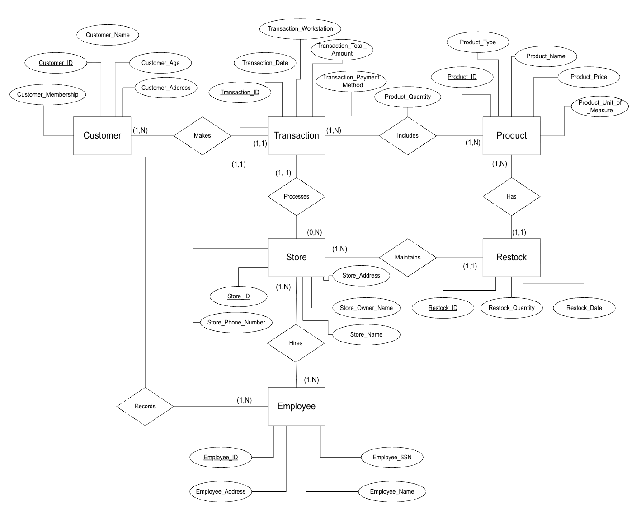
3. ER Diagram
The figure below shows the ER diagram of the Supermarket Database (SUPERMARKET).
4. ER Diagram Uncaptured Constraints
The following is a list of constraints that are not captured by the ER diagram of SUPERMARKET:
- The product price and employee salary must be positive and in dollars.
- Employee SSN must be unique.
- There is no self checkout, thus each transaction has a physical employee (not virtual).
- Employee can work at one store at a time
5. Relational Schema
This section provides the relational schema with referential integrity and the relational table details.
5.1 Relational Schema with Referential Integrity
Store (Store_ID, Store_Address, Store_Phone_Number, Store_Name,
Store_Owner_Name)

Employee (Employee_ID, Employee_Address, Employee_Name, Employee_SSN)

Hires (Store_ID, Employee_ID)
Foreign key (Store_ID) references Store (Store_ID)
Foreign key (Employee_ID) references Employee (Employee_ID)

Customer (Customer_ID, Customer_Name, Customer_Membership, Customer_Address, Customer_Age)

Product (Product_ID, Product_Type, Product_Name, Product_Price, Product_Unit_of_Measure)

Transaction (Transaction_ID, Transaction_Workstation, Transaction_Date, Transaction_Total_Amount, Transaction_Payment_Method, Employee_ID, Customer_ID, Store_ID)
Foreign key (Employee_ID) references Employee (Employee_ID)
Foreign key (Customer_ID) references Customer (Customer_ID)
Foreign key (Store_ID) references Store (Store_ID)

Includes (Transaction_ID, Product_ID, Product_Quantity)
Foreign key (Transaction_ID) references Transaction (Transaction_ID)
Foreign key (Product_ID) references Product (Product_ID)

Restock (Restock_ID, Restock_Date, Restock_Quantity, Store_ID, Product_ID)
Foreign key (Store_ID) references Store (Store_ID)
Foreign key (Product_ID) references Product (Product_ID)

5.2 Relational Table Details
The relational schema given in Section 5.1 was mapped into the following tables in the Supermarket Database (SUPERMARKET). Primary keys have been underlined. Tables that have multiple attributes underlined represent composite keys.
Table Name | Attribute | Description
Store | Store_ID | Unique Store ID
Store | Store_Address | Address of the Store
Store | Store_Phone_Number | Phone Number of Store
Store | Store_Name | Name of Store
Store | Store_Owner_Name | Name of the Store Owner
Employee | Employee_ID | Unique Employee ID
Employee | Employee_Address | Address of Employee
Employee | Employee_Name | Name of Employee
Employee | Employee_SSN | Social Security Number of Employee
Hires | Store_ID | Unique Store ID which Hires Employee
Hires | Employee_ID | Unique Employee ID that is Hired by Store
Customer | Customer_ID | Unique Customer ID
Customer | Customer_Name | Name of the Customer
Customer | Customer_Membership | Membership of Customer
Customer | Customer_Address | Address of Customer
Customer | Customer_Age | Age of Customer

Table Name | Attribute | Description
Product | Product_ID | Unique Product ID
Product | Product_Type | Type of Product
Product | Product_Name | Name of Product
Product | Product_Price | Price of Product
Product | Product_Unit_of_Measure | Unit of Measure of Product
Transaction | Transaction_ID | Unique Transaction ID
Transaction | Transaction_Workstation | Workstation of Transaction
Transaction | Transaction_Date | Date of Transaction
Transaction | Transaction_Total_Amount | Total Amount of Transaction
Transaction | Transaction_Payment_Method | Payment Method of Transaction
Transaction | Employee_ID | ID of Employee Recording the Transaction
Transaction | Customer_ID | ID of Customer Making Transaction
Transaction | Store_ID | ID of Store Processing Transaction
Includes | Transaction_ID | Unique ID of Transaction Including that Product
Includes | Product_ID | Unique ID of the Product which Includes Transaction
Includes | Product_Quantity | Quantity of Product
Restock | Restock_ID | Unique Restock ID
Restock | Restock_Date | Date of Restock
Restock | Restock_Quantity | Quantity of Restock
Restock | Store_ID | ID of Store Maintaining the Restock
Restock | Product_ID | ID of Product that has the Restock

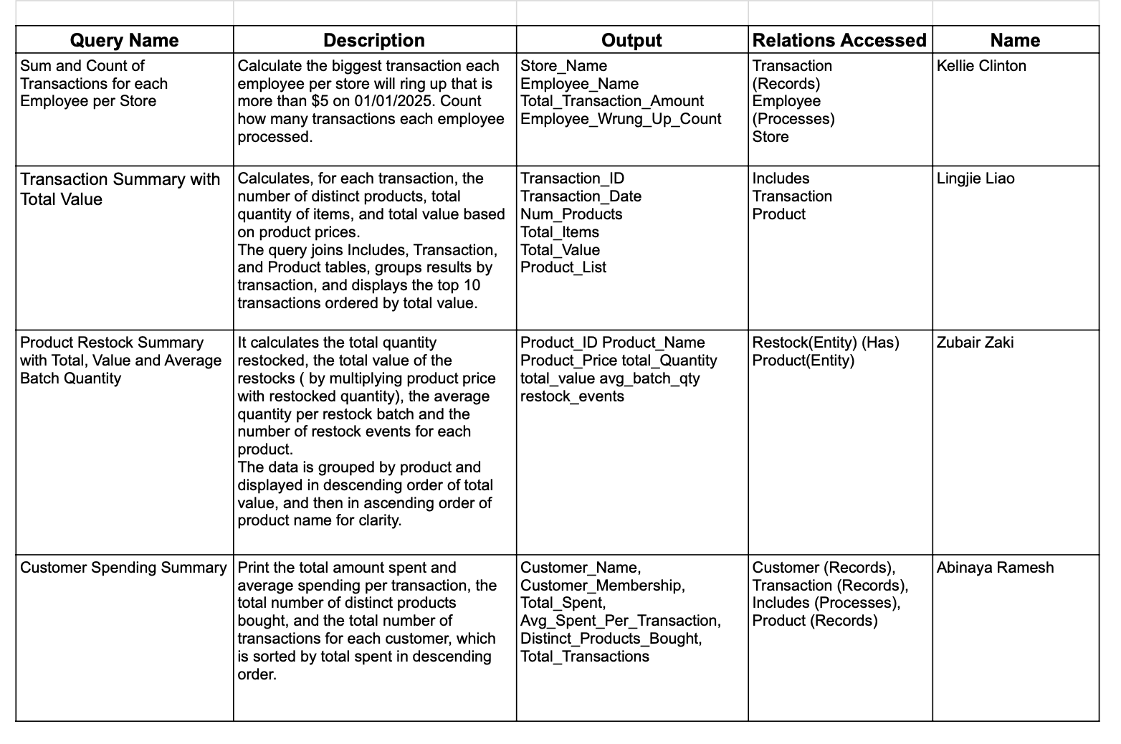
6. Queries

​​7. DDL + DML + SQL (Including output screenshots)
The following is an SQL definition of the tables for the SUPERMARKET Database.

CREATE TABLE Transaction (
Transaction_ID integer NOT NULL,
Transaction_Date date,
Transaction_Workstation varchar(20),
Transaction_Total_Amount numeric,
Transaction_Payment_Method varchar(20),
Employee_ID integer,
Store_ID integer,
Customer_ID integer,
PRIMARY KEY(Transaction_ID),
FOREIGN KEY (Employee_ID) REFERENCES Employee(Employee_ID),
FOREIGN KEY (Store_ID) REFERENCES Store(Store_ID),
FOREIGN KEY (Customer_ID) REFERENCES Customer(Customer_ID));

CREATE TABLE Store(
Store_ID integer,
Store_Phone_Number varchar(20),
Store_Address varchar(255),
Store_Name varchar(20),
Store_Owner_Name varchar(50),
PRIMARY KEY (Store_ID));

CREATE TABLE Employee(
Employee_ID integer,
Employee_SSN varchar(20),
Employee_Address varchar(255),
Employee_Name varchar(20),
PRIMARY KEY (Employee_ID));

CREATE TABLE Product(
Product_ID integer,
Product_Type varchar(50) NOT NULL,
Product_Name varchar(40) NOT NULL,
Product_Price numeric,
Product_Unit_Of_Measure varchar(40),
PRIMARY KEY (Product_ID));

CREATE TABLE Includes(
Transaction_ID integer,
Product_ID integer,
Product_Quantity integer,
PRIMARY KEY (Transaction_ID, Product_ID),
FOREIGN KEY (Transaction_ID) REFERENCES Transaction (Transaction_ID),
FOREIGN KEY (Product_ID) REFERENCES Product (Product_ID));

CREATE TABLE Restock(
Restock_ID integer,
Store_ID integer,
Product_ID integer,
Restock_Quantity integer,
Restock_Date date,
PRIMARY KEY (Restock_ID),
FOREIGN KEY (Store_ID) REFERENCES Store (Store_ID),
FOREIGN KEY (Product_ID) REFERENCES Product (Product_ID));

CREATE TABLE Customer (
Customer_ID integer PRIMARY KEY,
Customer_Name VARCHAR(50) NOT NULL,
Customer_Membership VARCHAR(20) CHECK (Customer_Membership IN ('Gold', 'Silver', 'Bronze')),
Customer_Address varchar(100),
Customer_Age integer CHECK (Customer_Age > 0));

INSERT INTO Employee VALUES
(0001, '999-88-7777', '202 Broadway St', 'Julie Pumpkin'),
(0002, '212-63-4512', '144 Colfax Rd', 'Nancy Lemon'),
(0003, '747-00-8539', '555 Luna Rd', 'Tom Schwarts'),
(0004, '963-52-7219', '998 Plum Grove St', 'Rachel Lime'),
(0005, '417-77-8860', '231 Heather Ct', 'Dan Arnold'),
(0006, '551-27-9437', '741 Kennedy Rd', 'Sally Seashell');

INSERT INTO Customer VALUES
(001, 'Alice', 'Gold', '123 Main Street, Chicago', 28),
(002, 'Bob', 'Silver', '45 Lake View Drive, Chicago', 34),
(003, 'Carol', 'Gold', '789 Oak Lane, Evanston', 26),
(004, 'David', 'Bronze', '56 Pine Road, Naperville', 40),
(005, 'Emma', 'Silver', '91 River Street, Aurora', 31),
(006, 'Frank', 'Gold', '32 Maple Avenue, Skokie', 29),
(007, 'Grace', 'Bronze', '210 Hilltop Street, Chicago', 37);

INSERT INTO Transaction VALUES
(0001, ('01/01/2025'), 'WS-001', 60, 'Credit Card', 0001, 0001,001),
(0002, ('01/01/2025'), 'WS-002', 10, 'Check', 0002, 0004,002),
(0003, ('01/01/2025'), 'WS-003', 45, 'Credit Card', 0003, 0004,003),
(0004, ('01/01/2025'), 'WS-004', 105, 'Credit Card', 0002, 0004,001),
(0005, ('01/01/2025'), 'WS-005', 25, 'Direct Deposit', 0005, 0006,004),
(0006, ('01/01/2025'), 'WS-005', 3, 'Credit Card', 0005, 0006,005),
(0007, ('01/01/2025'), 'WS-003', 112, 'Check', 0004, 0004,002),
(0008, ('01/01/2025'), 'WS-005', 56, 'Cash', 0005, 0006,003),
(0009, ('01/01/2025'), 'WS-001', 47, 'Credit Card', 0005, 0006,007),
(0010, ('01/02/2025'), 'WS-002', 87, 'Cash', 0005, 0006, 006);

INSERT INTO Store VALUES
(0001, '1+555-123-3456', '123 Main St', 'Jewel', 'Joe Smith'),
(0002, '1+630-255-4788', '711 Smile St', 'Kroger', 'Bill Gates'),
(0003, '1+224-124-7489', '411 Sad St', 'Aldi', 'Jill Bob'),
(0004, '1+847-514-6347', '789 Smith Rd', 'Win-Dixie', 'Barb Santos'),
(0005, '1+630-417-3697', '100 Acre Wood', 'Walmart', 'Piglet Eeyore'),
(0006, '1+847-898-4563', '1725 Slough Avenue', 'Target', 'Michael Scott');

INSERT INTO Product VALUES
(1001, 'Beverage', 'Coca-Cola Can', 1.25, 'per can'),
(1002, 'Beverage', 'Orange Juice', 3.50, 'per bottle'),
(1003, 'Snack', 'Potato Chips', 2.00, 'per pack'),
(1004, 'Grocery', 'Whole Wheat Bread', 2.75, 'per loaf'),
(1005, 'Grocery', 'Brown Rice', 5.00, 'per kg'),
(1006, 'Personal Care', 'Toothpaste', 4.25, 'per tube'),
(1007, 'Electronics', 'AA Batteries', 7.00, 'per pack'),
(1008, 'Stationery', 'Ballpoint Pen', 1.10, 'per piece');

INSERT INTO Includes VALUES
(0001, 1001, 2),
(0001, 1003, 1),
(0002, 1002, 1),
(0003, 1004, 2),
(0004, 1005, 1),
(0005, 1006, 1),
(0006, 1007, 2),
(0007, 1008, 3),
(0008, 1001, 1),
(0008, 1003, 1);

INSERT INTO Restock VALUES
(9001, 0001, 1001, 50, '2025-01-01'),
(9002, 0001, 1003, 30, '2025-01-02'),
(9003, 0002, 1002, 40, '2025-01-03'),
(9004, 0003, 1004, 25, '2025-01-04'),
(9005, 0004, 1005, 60, '2025-01-05'),
(9006, 0005, 1006, 20, '2025-01-05'),
(9007, 0005, 1007, 15, '2025-01-06'),
(9008, 0006, 1008, 80, '2025-01-07'),
(9009, 0004, 1001, 40, '2025-01-08'),
(9010, 0002, 1004, 25, '2025-01-09');

- Kellie Clinton
- Sum and Count of Transactions for each Employee per Store
- Calculate the biggest transaction each employee per store will ring up that is more than $5 on 01/01/2025. Count how many transactions each employee processed.
SELECT S.Store_Name, E.Employee_Name, SUM (T.Transaction_Total_Amount) AS Total_Transaction_Amount, Count (E.Employee_ID) AS Employee_Wrung_Up_Count
FROM Transaction T, Store S, Employee E
WHERE T.Employee_ID = E.Employee_ID AND
T.Store_ID = S.Store_ID AND
T.Transaction_Date = '01/01/2025'
GROUP BY S.Store_ID, E.Employee_ID
HAVING SUM(T.Transaction_Total_Amount) > 5
ORDER BY Sum(T.Transaction_Total_Amount) DESC;

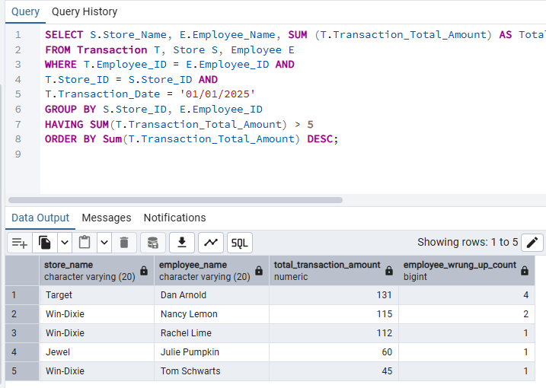

- Lingjie Liao
- Transaction Summary with Total Value
- Calculates, for each transaction, the number of distinct products, total quantity, and total value based on product prices.
Joins Includes, Transaction, and Product tables, groups results by transaction, and displays the top 10 transactions ordered by total value.

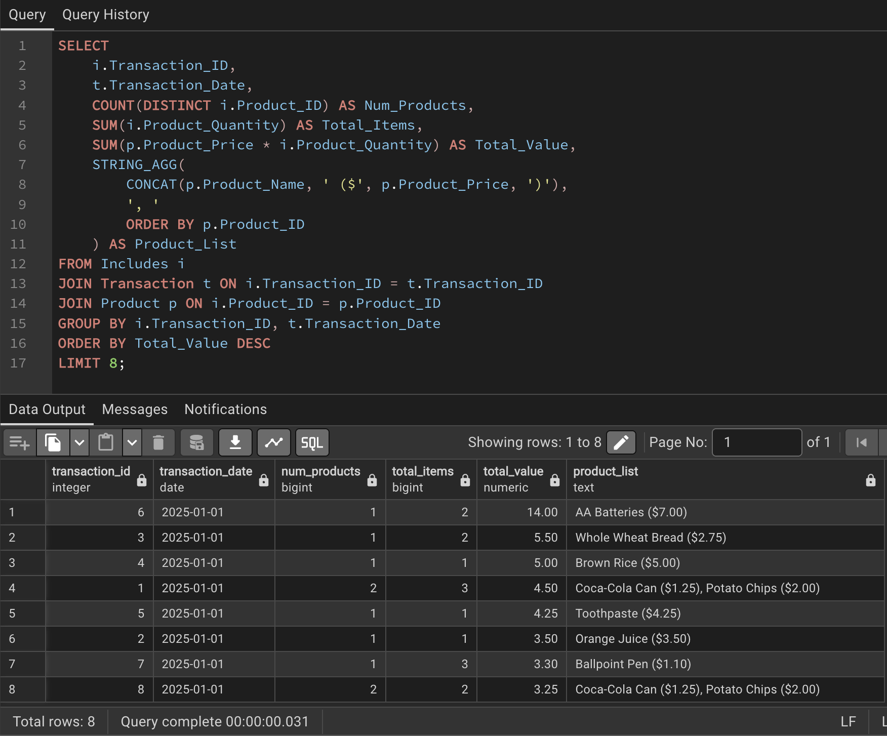
- Zubair Zaki
- Product Restock Summary with Total, Value and Average Batch Quantity.
- Find the total restocked quantity and total restocked value (price × quantity), Average Quantity Restocked and total number of restock events for each product type which is sorted by total value Descending order and name is Ascending order
SELECT P.Product_ID, P.Product_Name, P.Product_Price, SUM (R.Restock_Quantity) AS Total_Quantity, SUM (P.Product_Price * R.Restock_Quantity) AS Total_Value, AVG(r.restock_quantity) AS avg_batch_qty, COUNT (r.store_id) AS restock_events
FROM Restock R
JOIN Product P ON P.Product_ID = R.Product_ID
GROUP BY P.Product_ID, P.Product_Type, P.Product_Price
ORDER BY Total_Value DESC, P.Product_Name ASC;
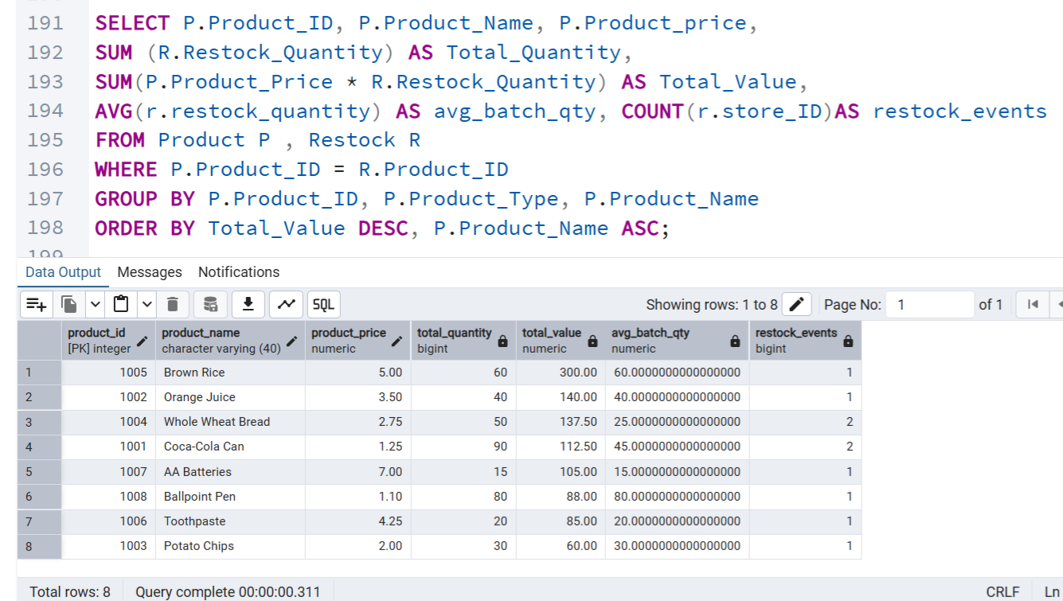
- Abinaya Ramesh
- Customer Spending Summary
- Print the total amount spent and average spending per transaction, the total number of distinct products bought, and the total number of transactions for each customer, which is sorted by total spent in descending order.

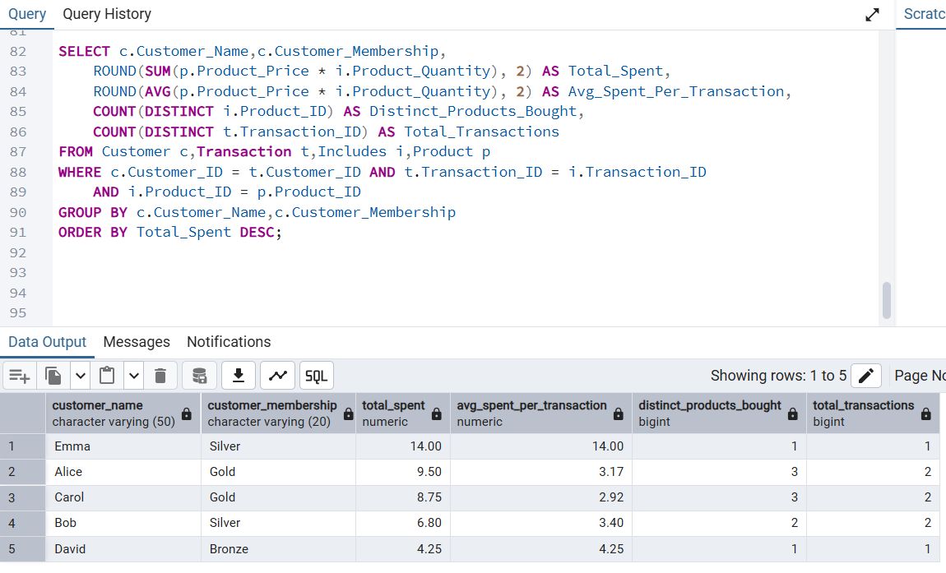

7. ORM Implementation

Kellie Clinton
- Create classes for N-N relationship of Hires, Store and Employee
Create Table:
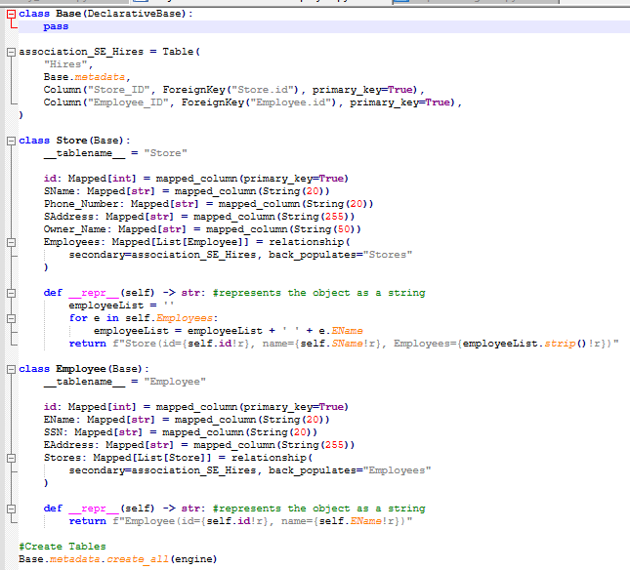

Insert Data:
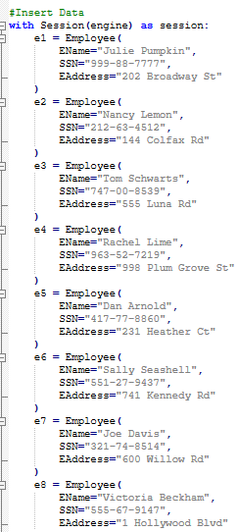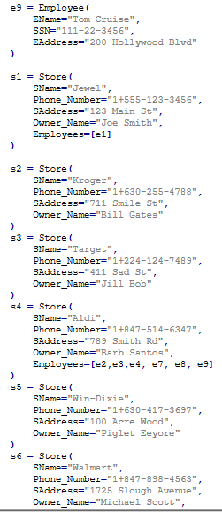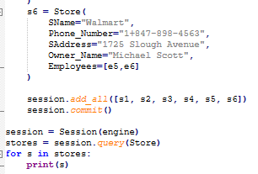
Query:
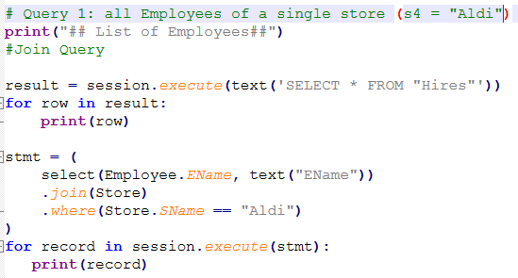
Query Output:
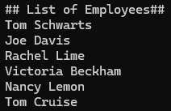

Lingjie Liao

Create 1-N Tables: Customer and Transaction

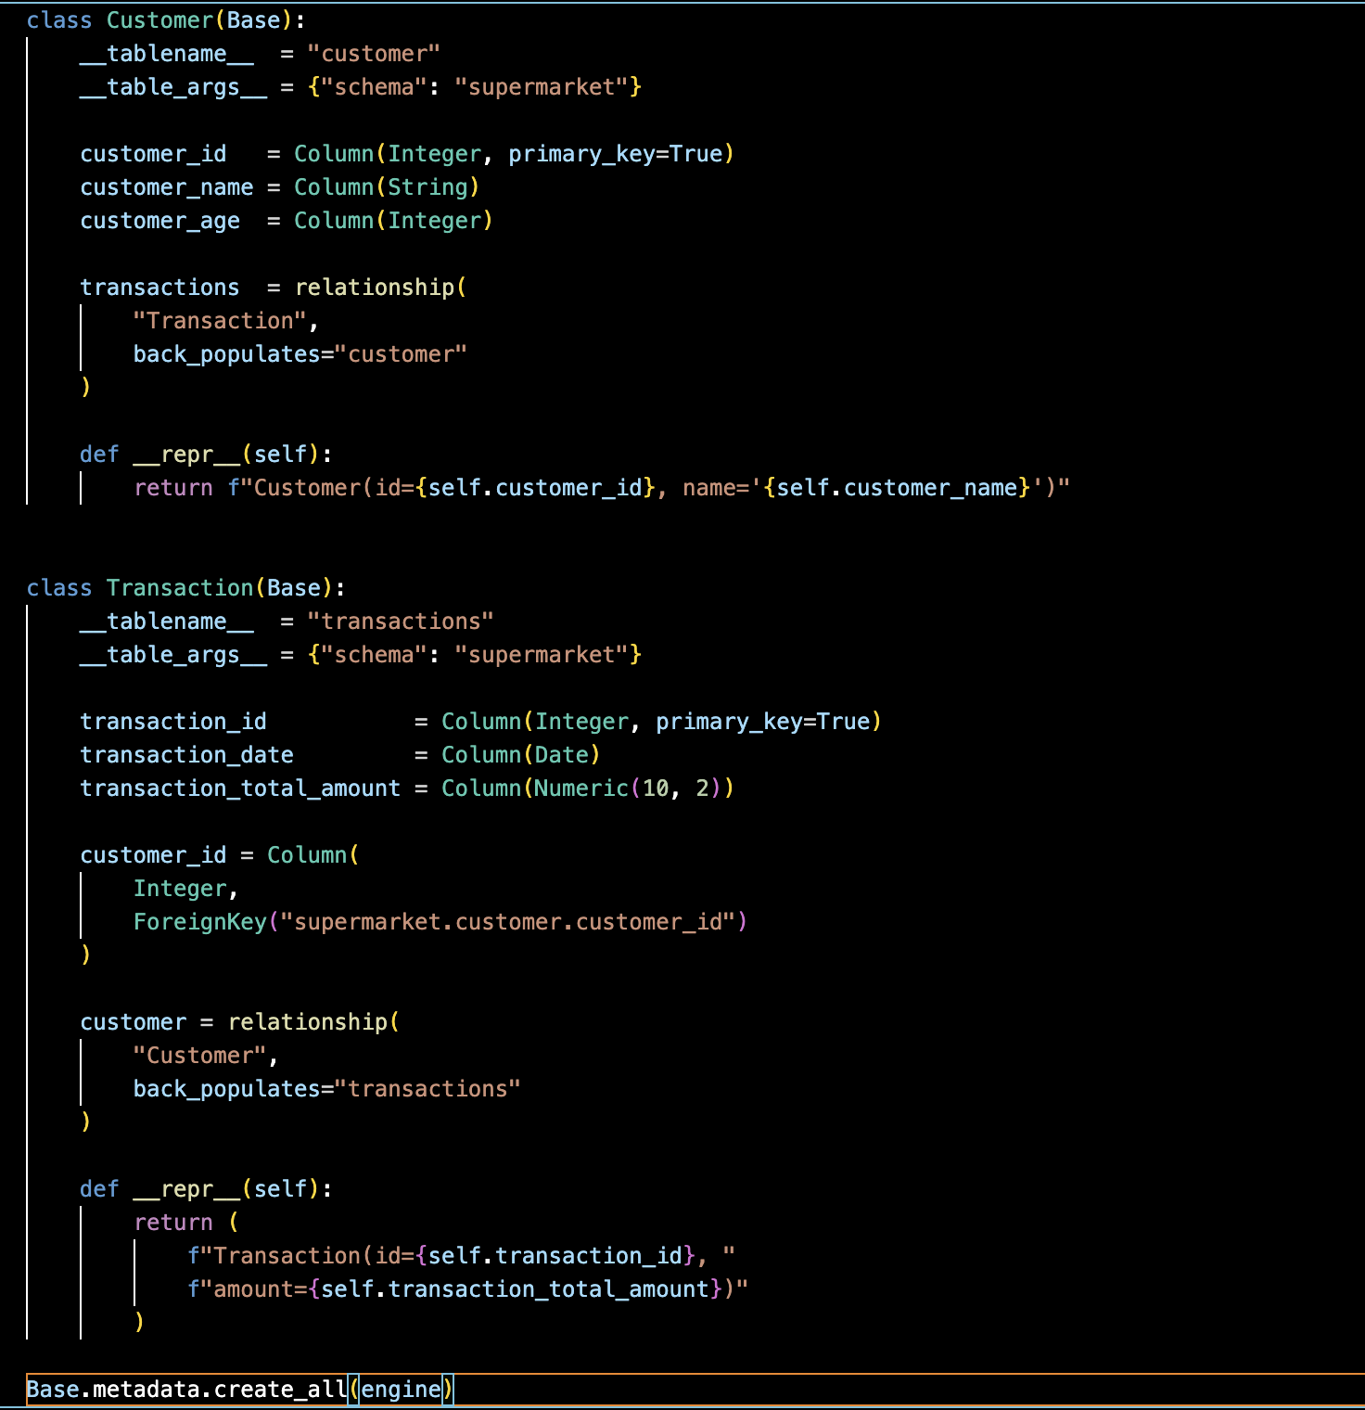

Insert Data
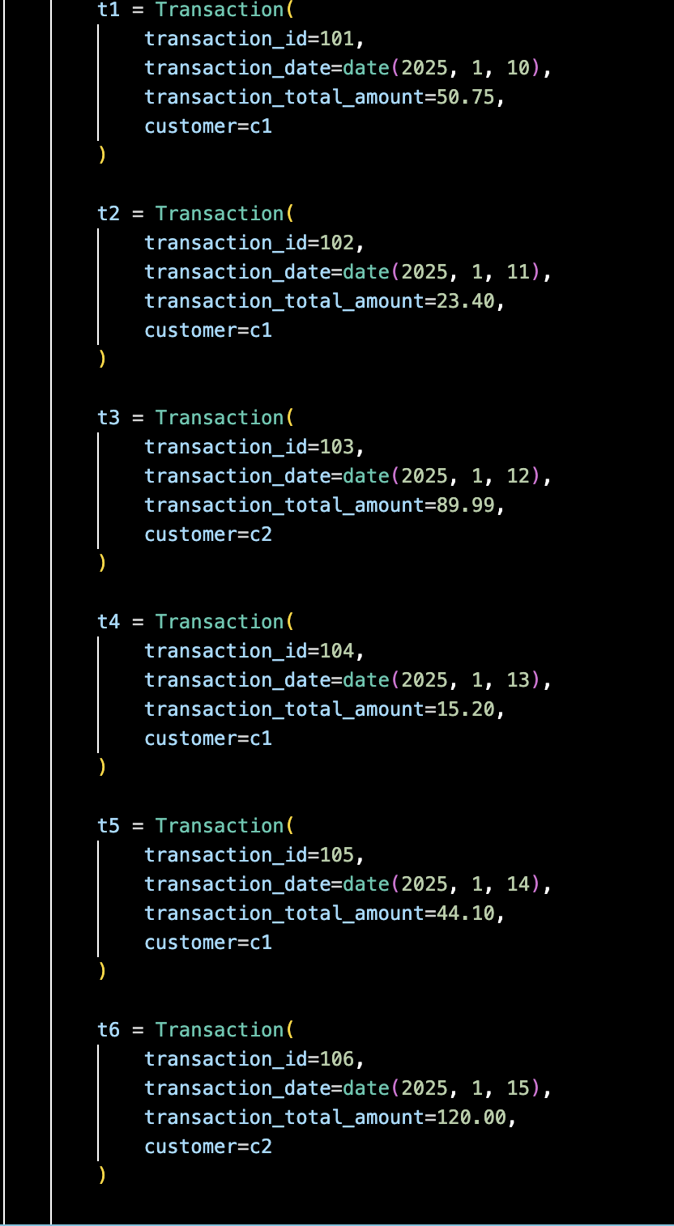
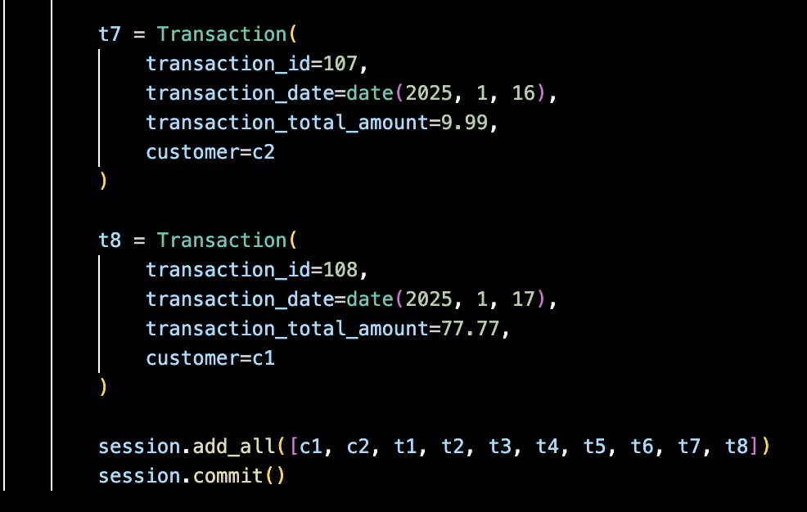

Query: List all transactions for each customer

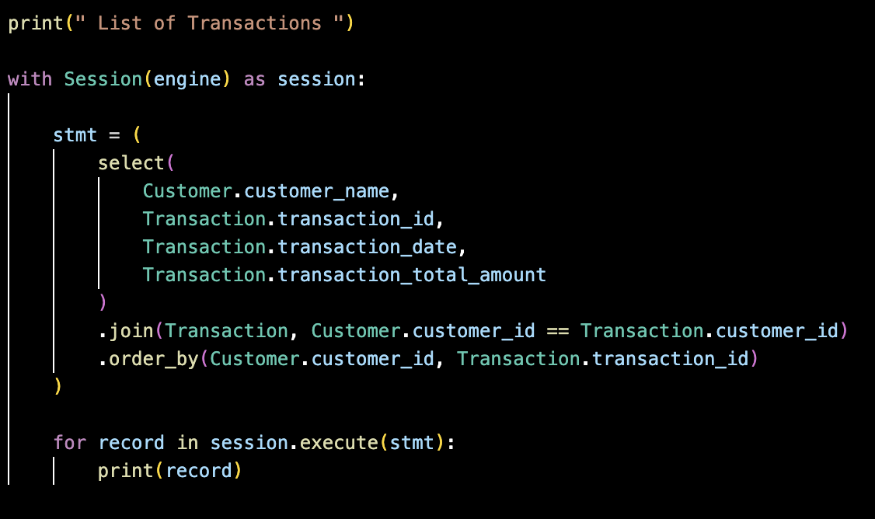

Output
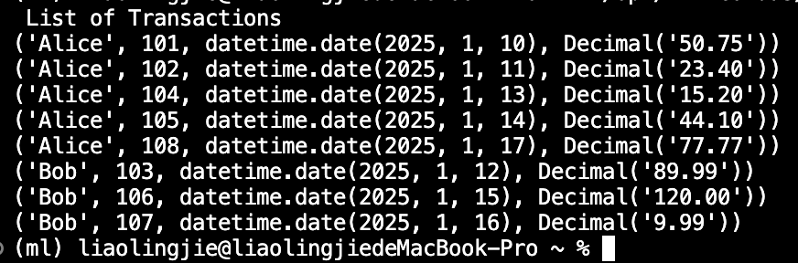
Zubair Zaki
Create 1-N tables: Product to restock
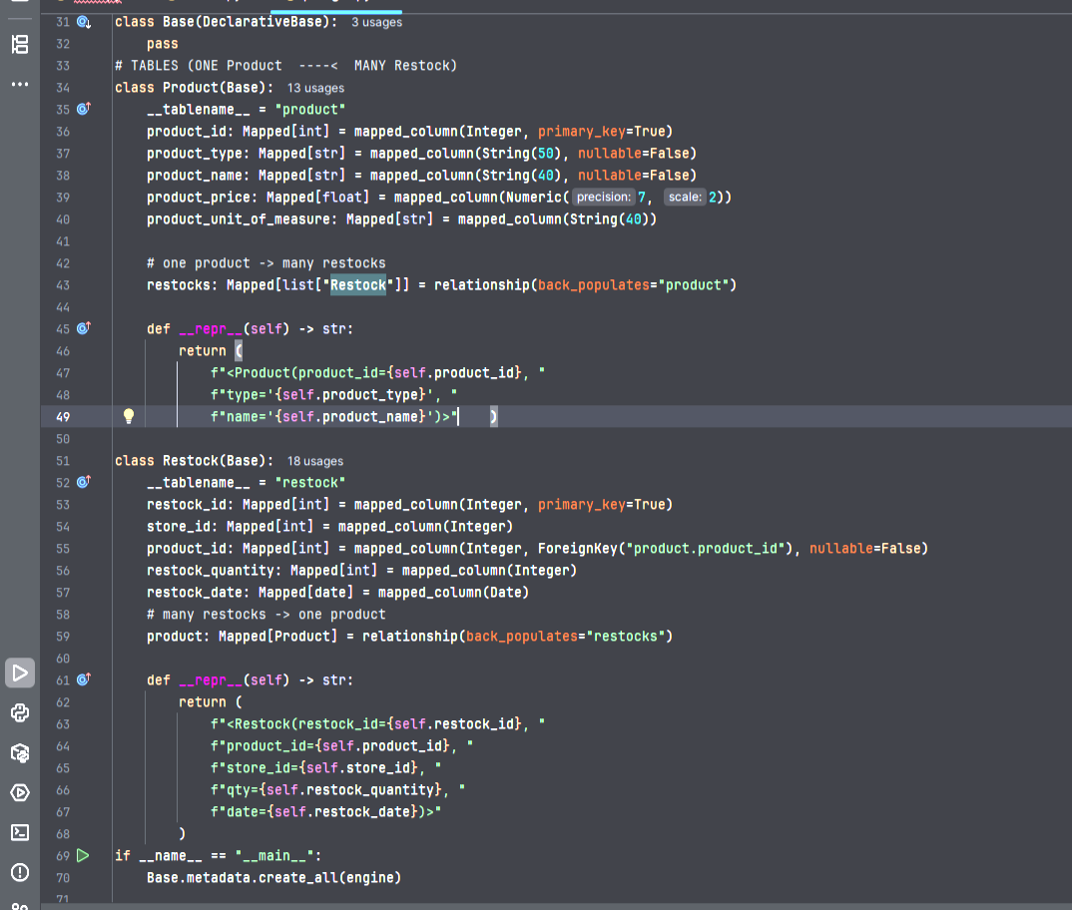

Insert Data
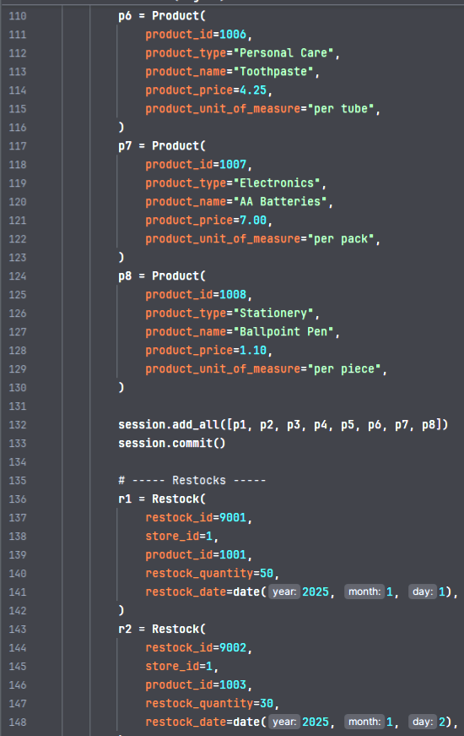
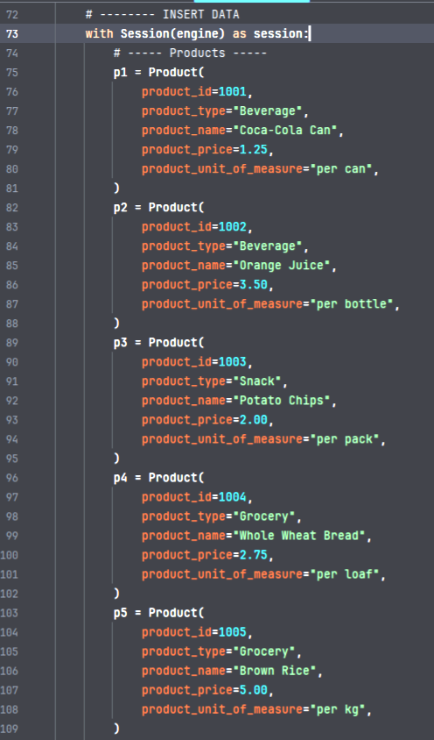

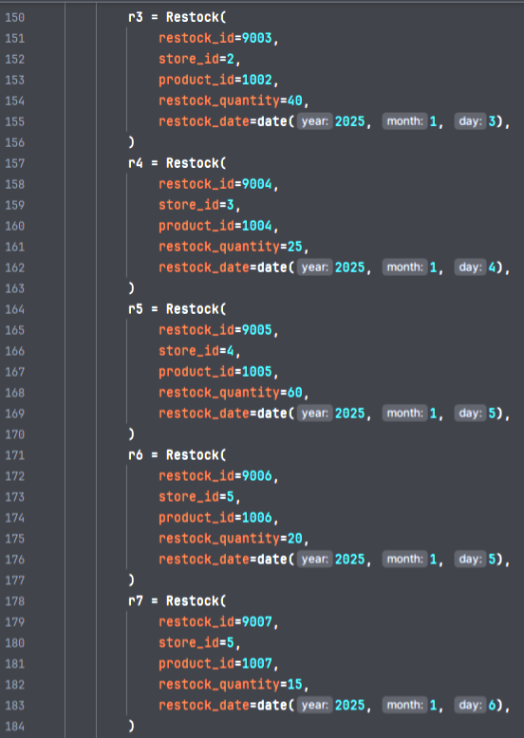 | 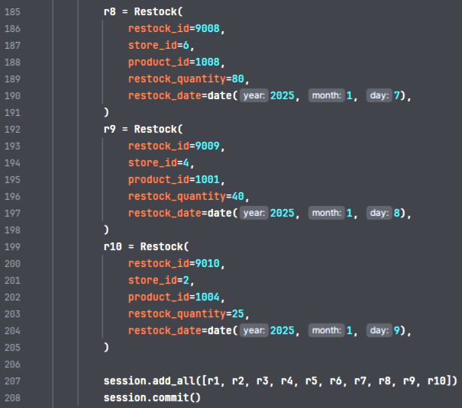

Query: List of All the Restocks with product details

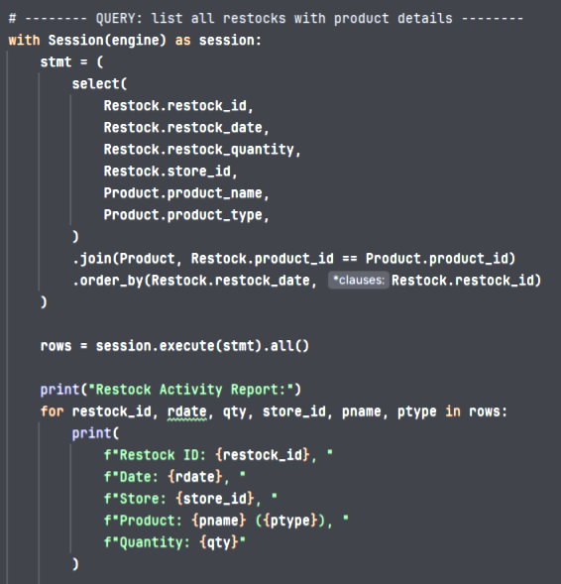

Output

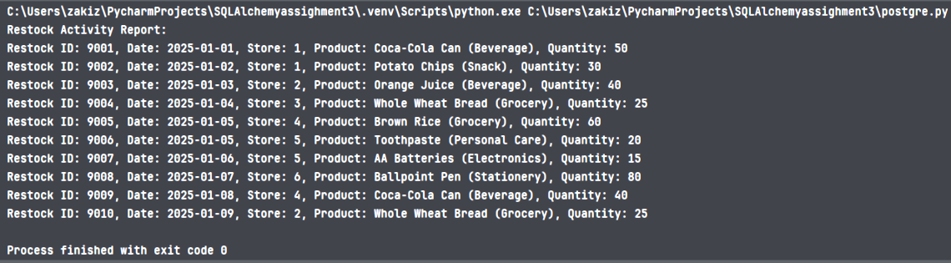

ABINAYA RAMESH
Create 1-N tables: Transaction and Store.

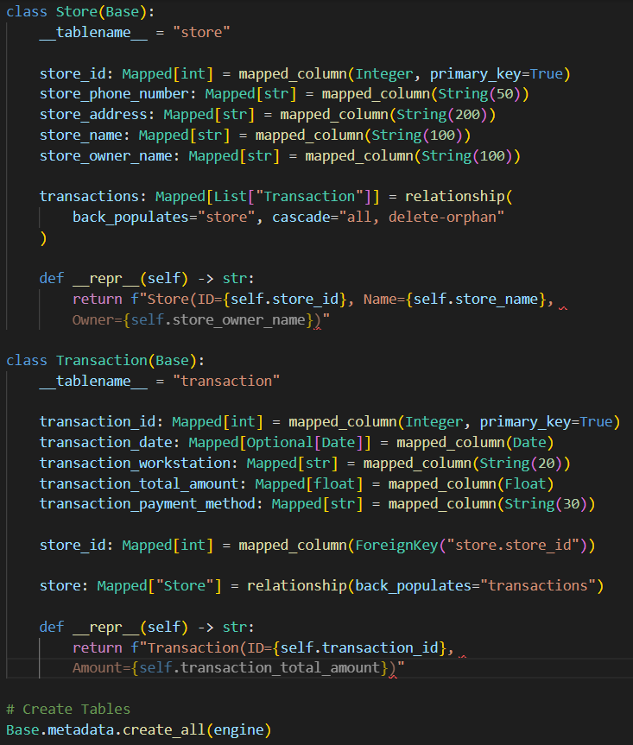

Insert Data
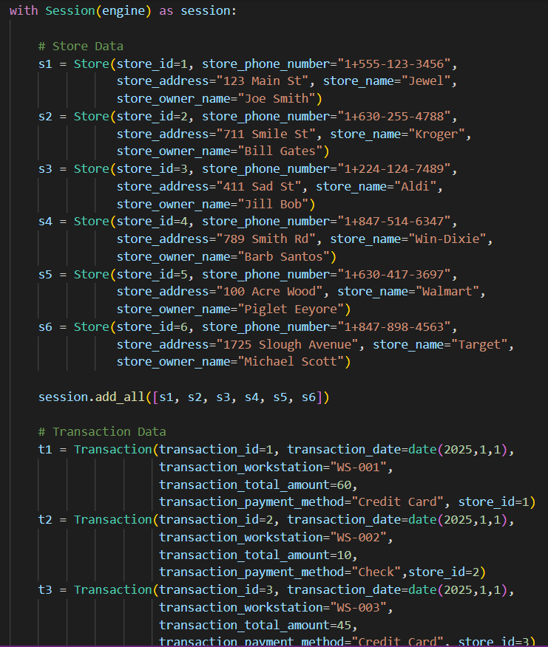

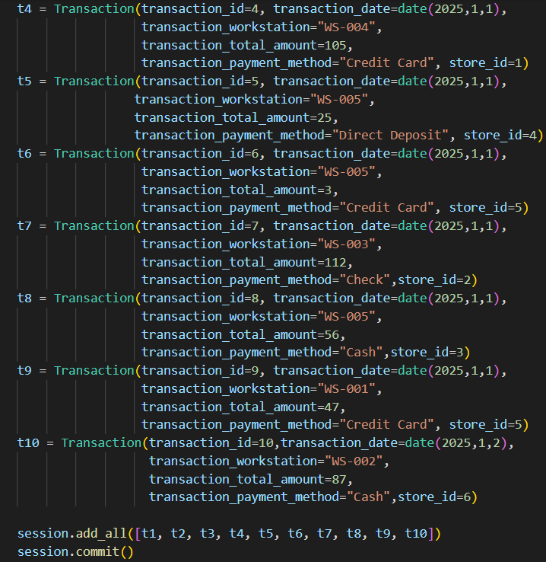

Query: List all transactions paid by Credit Card.

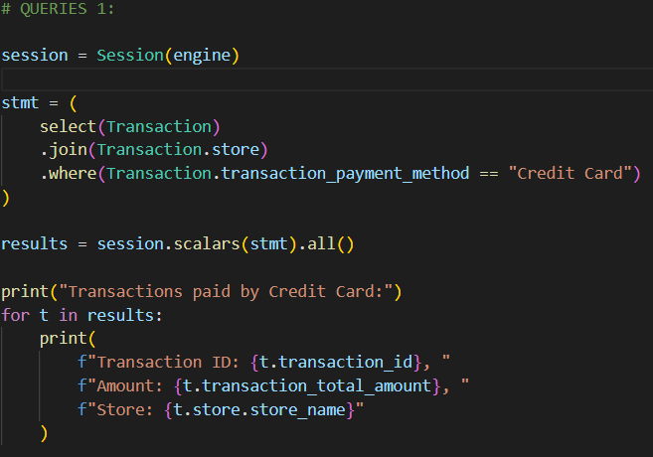

Output:
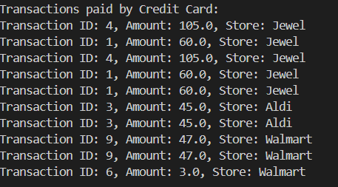

GROUP STATUS REPORT
GROUP #: 1 GROUP NAME: Dashers PHASE #: 3
Dates & attendance at group meetings in this phase:
Thursday, Nov 06 12:00 - 12:30 pm All group members present
Wednesday, Oct 22 1:00 - 2:00 pm Lingjie Liao & Kellie Clinton & Prof

Overview of progress on project as of <November 06>
Discussed who will do which entity relationship. The team will meet with the professor on Tuesday, 11/11 to review the code. After class that day, the team will meet to discuss the presentation.

CONTRIBUTIONS OF GROUP MEMBERS
Leader: Abinaya Ramesh
- Organized and compiled the team’s meeting reports and progress notes.
- Create classes for 1-N relationship of Customer and Transaction
Recorder: Zubair Zaki
- Check all sections of the report to ensure it was ready for submission.
- Create classes for 1-N relationship of Product and Restock
Phase Checker: Lingjie Liao
- Format Queries section and included it in the final documentation.
- Create classes for 1-N relationship of Customer and Transaction
Technical Advisor: Kellie Clinton
- Coordinated the overall formatting and consistency of the final report.
- Create classes for N-N relationship of Hires, Store and Employee

